Dominos Business Analytics

***Key Performance Indicators : (using SQL)***

1. Select the total number of orders placed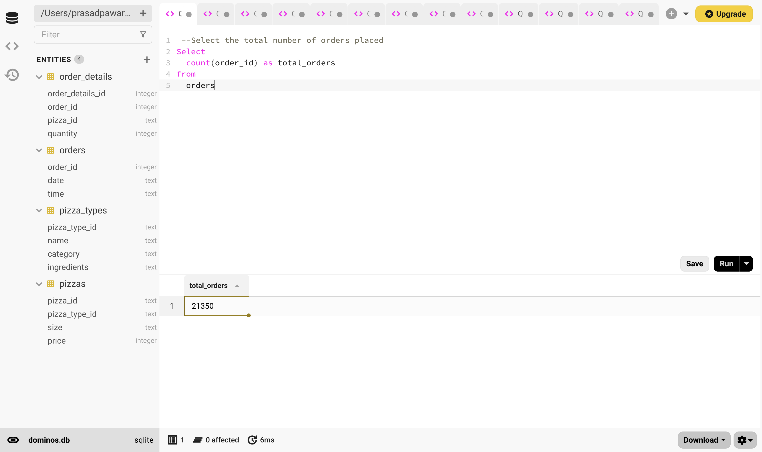
2. Calculate total revenue generated from Pizza sales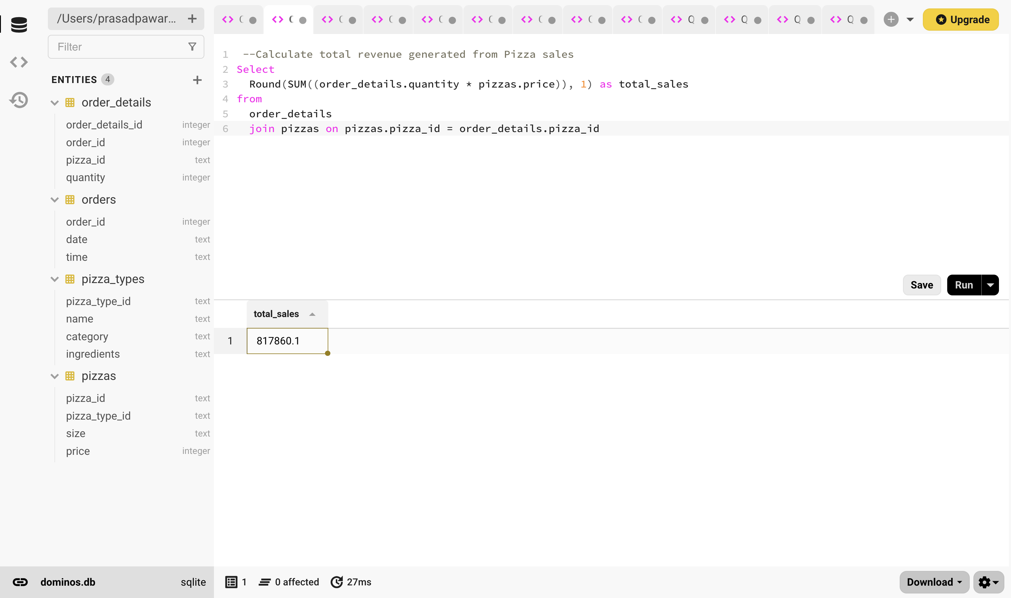
3. Identify the highest price pizza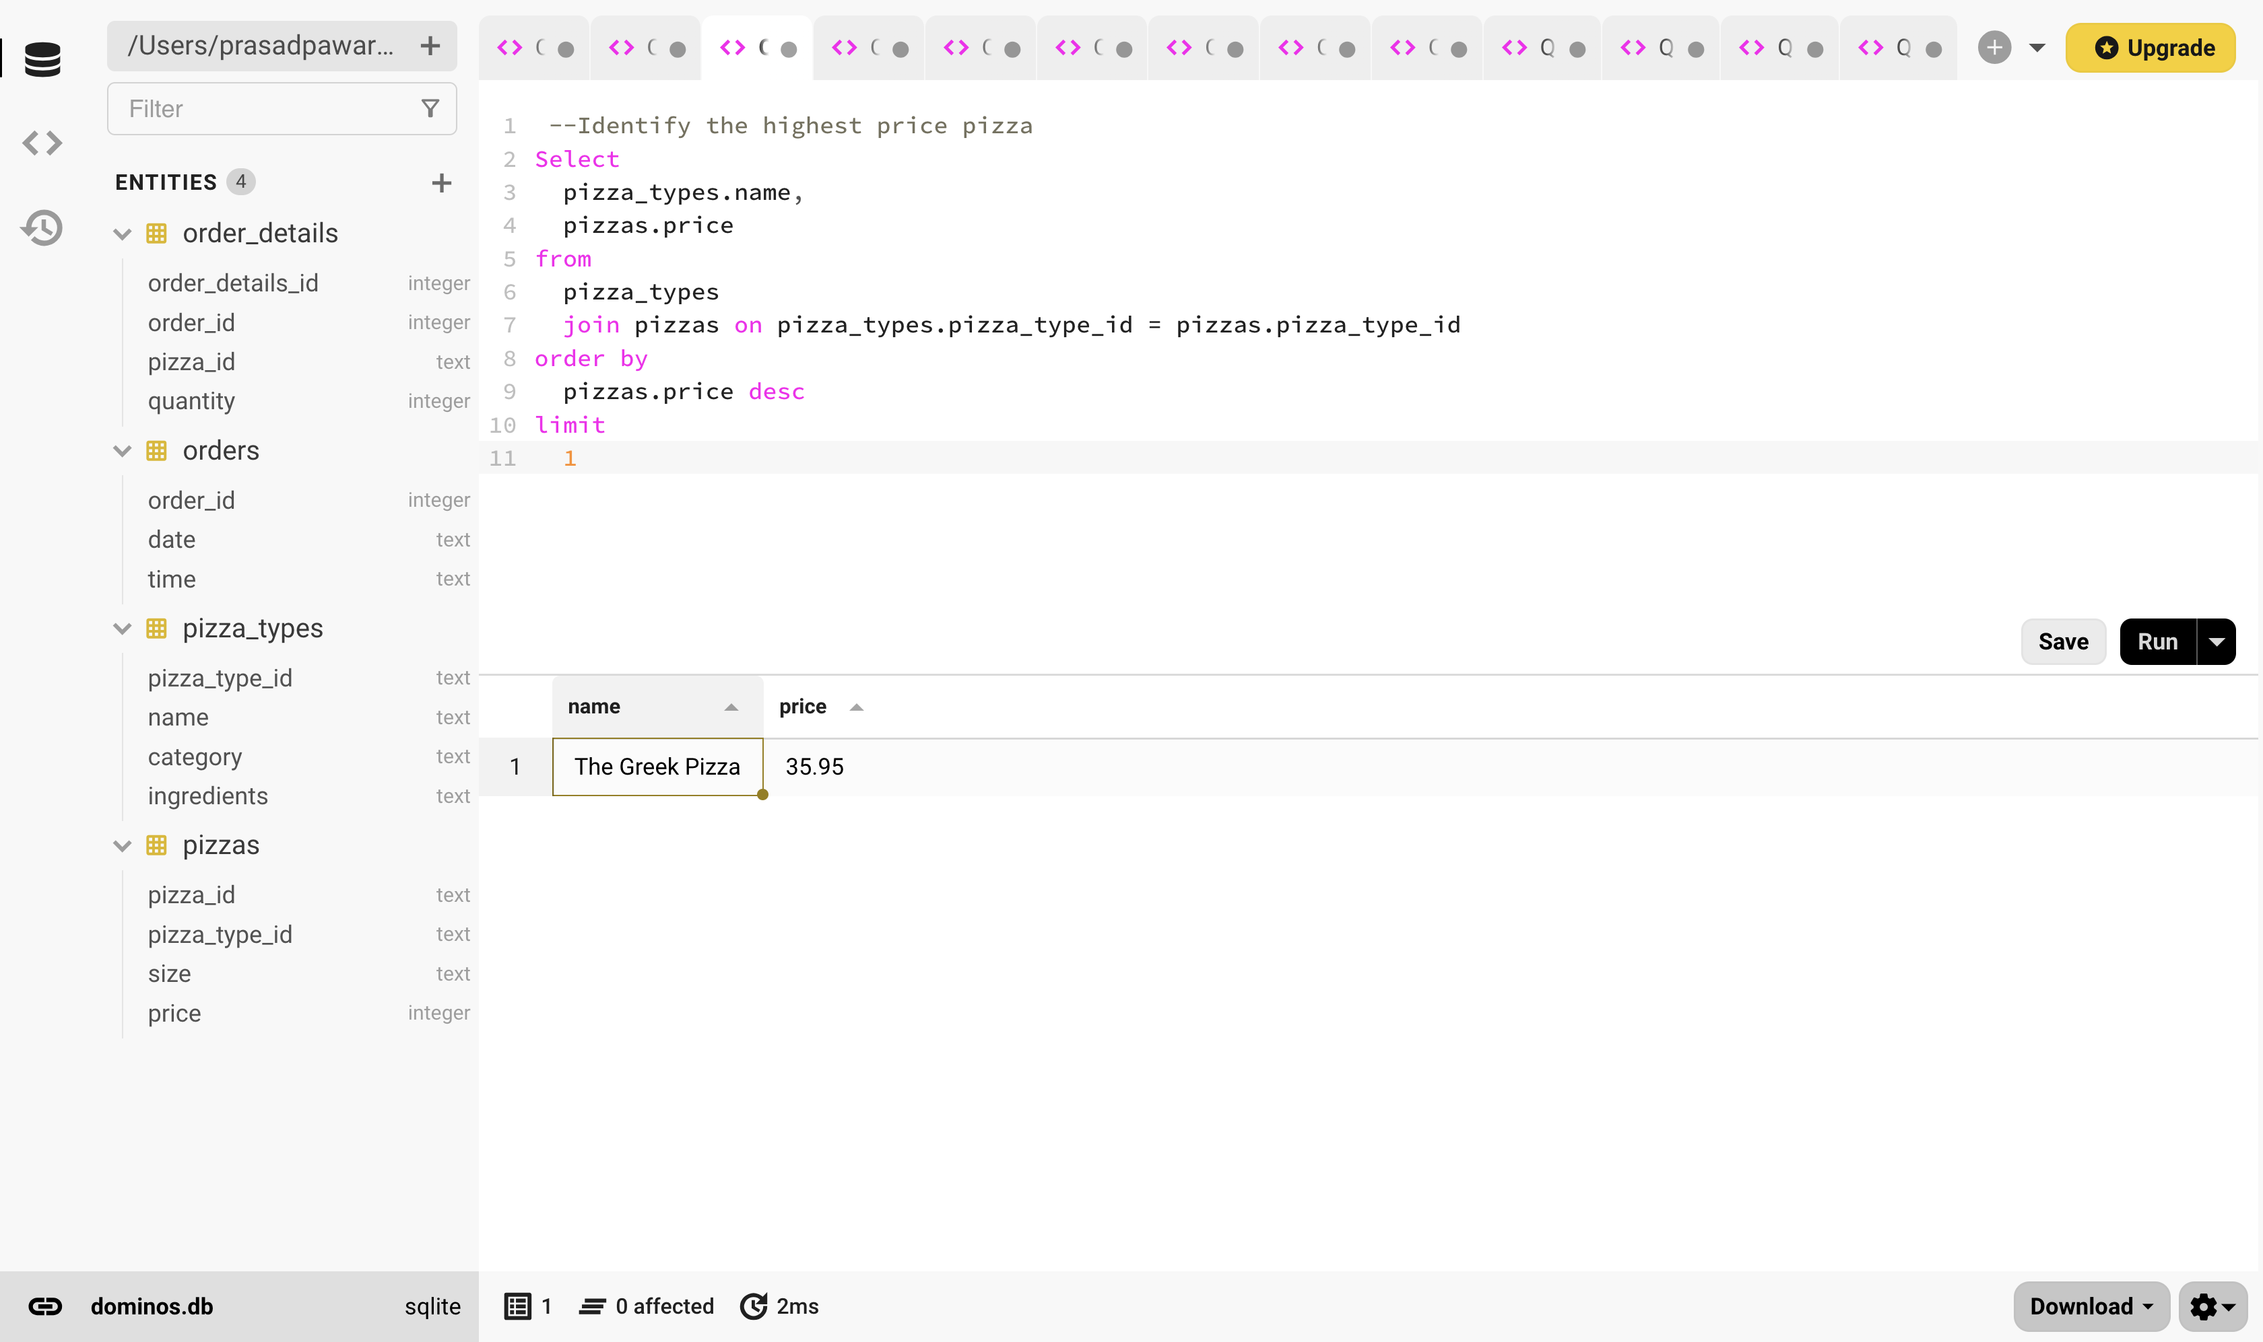
4. Identity the most common size pizza ordered

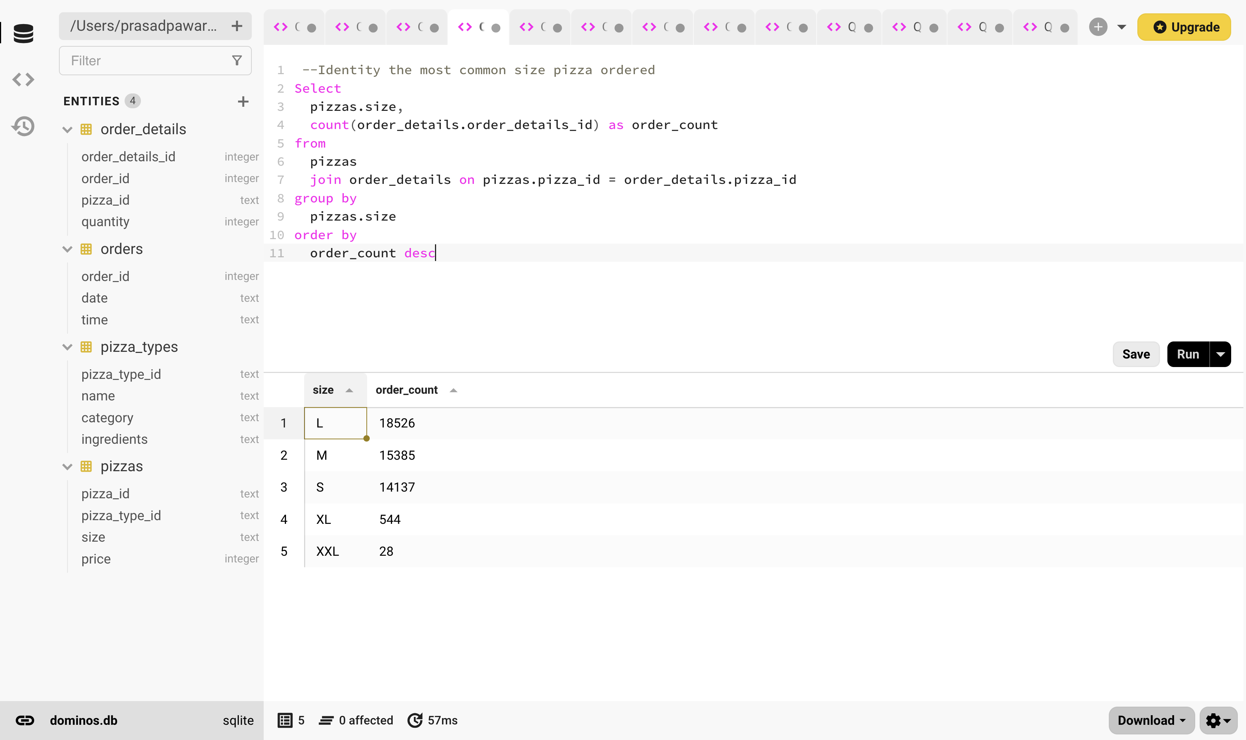

1. List the top 5 most ordered pizza types along with their quantities.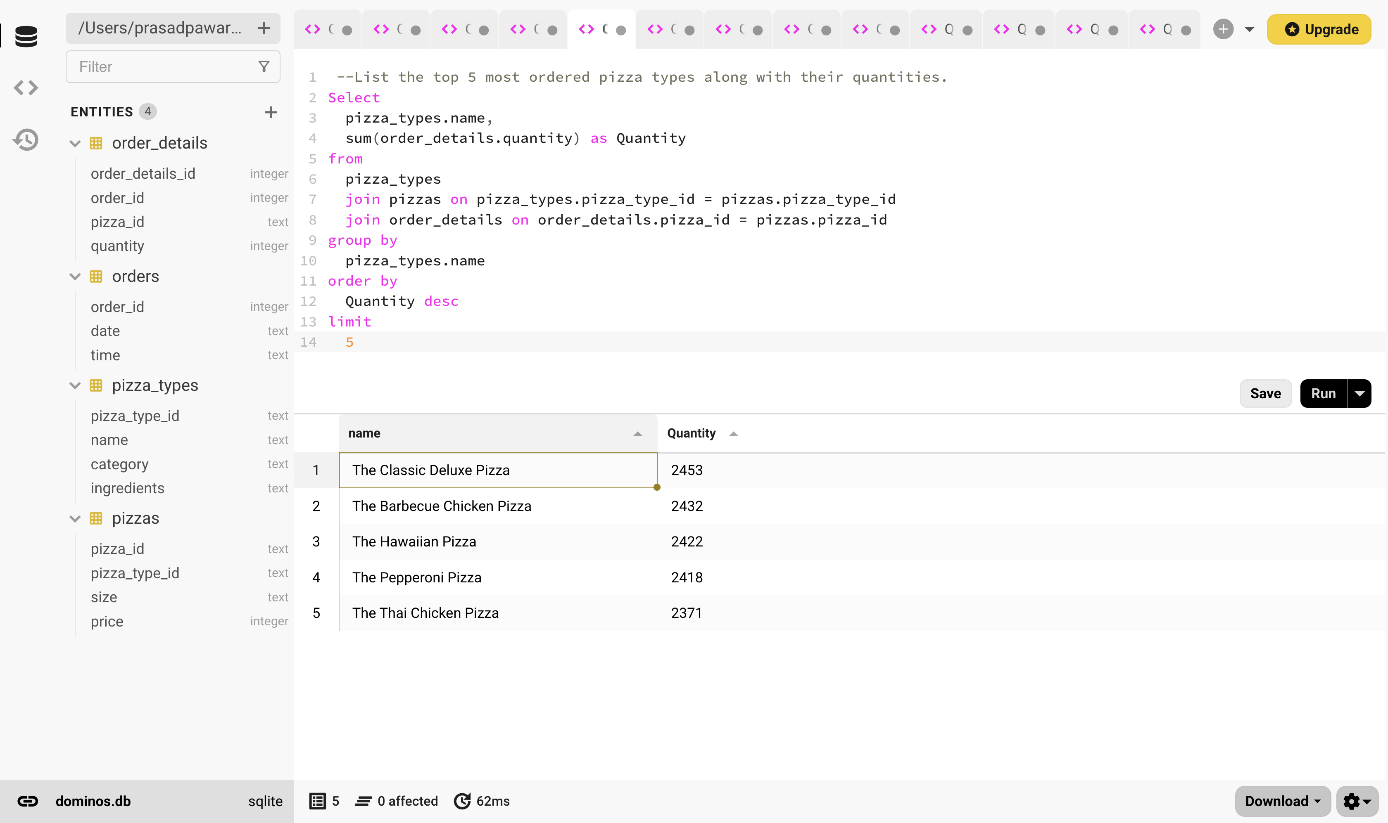
2. Join the necessary tables to find the total quantity of each pizza category ordered.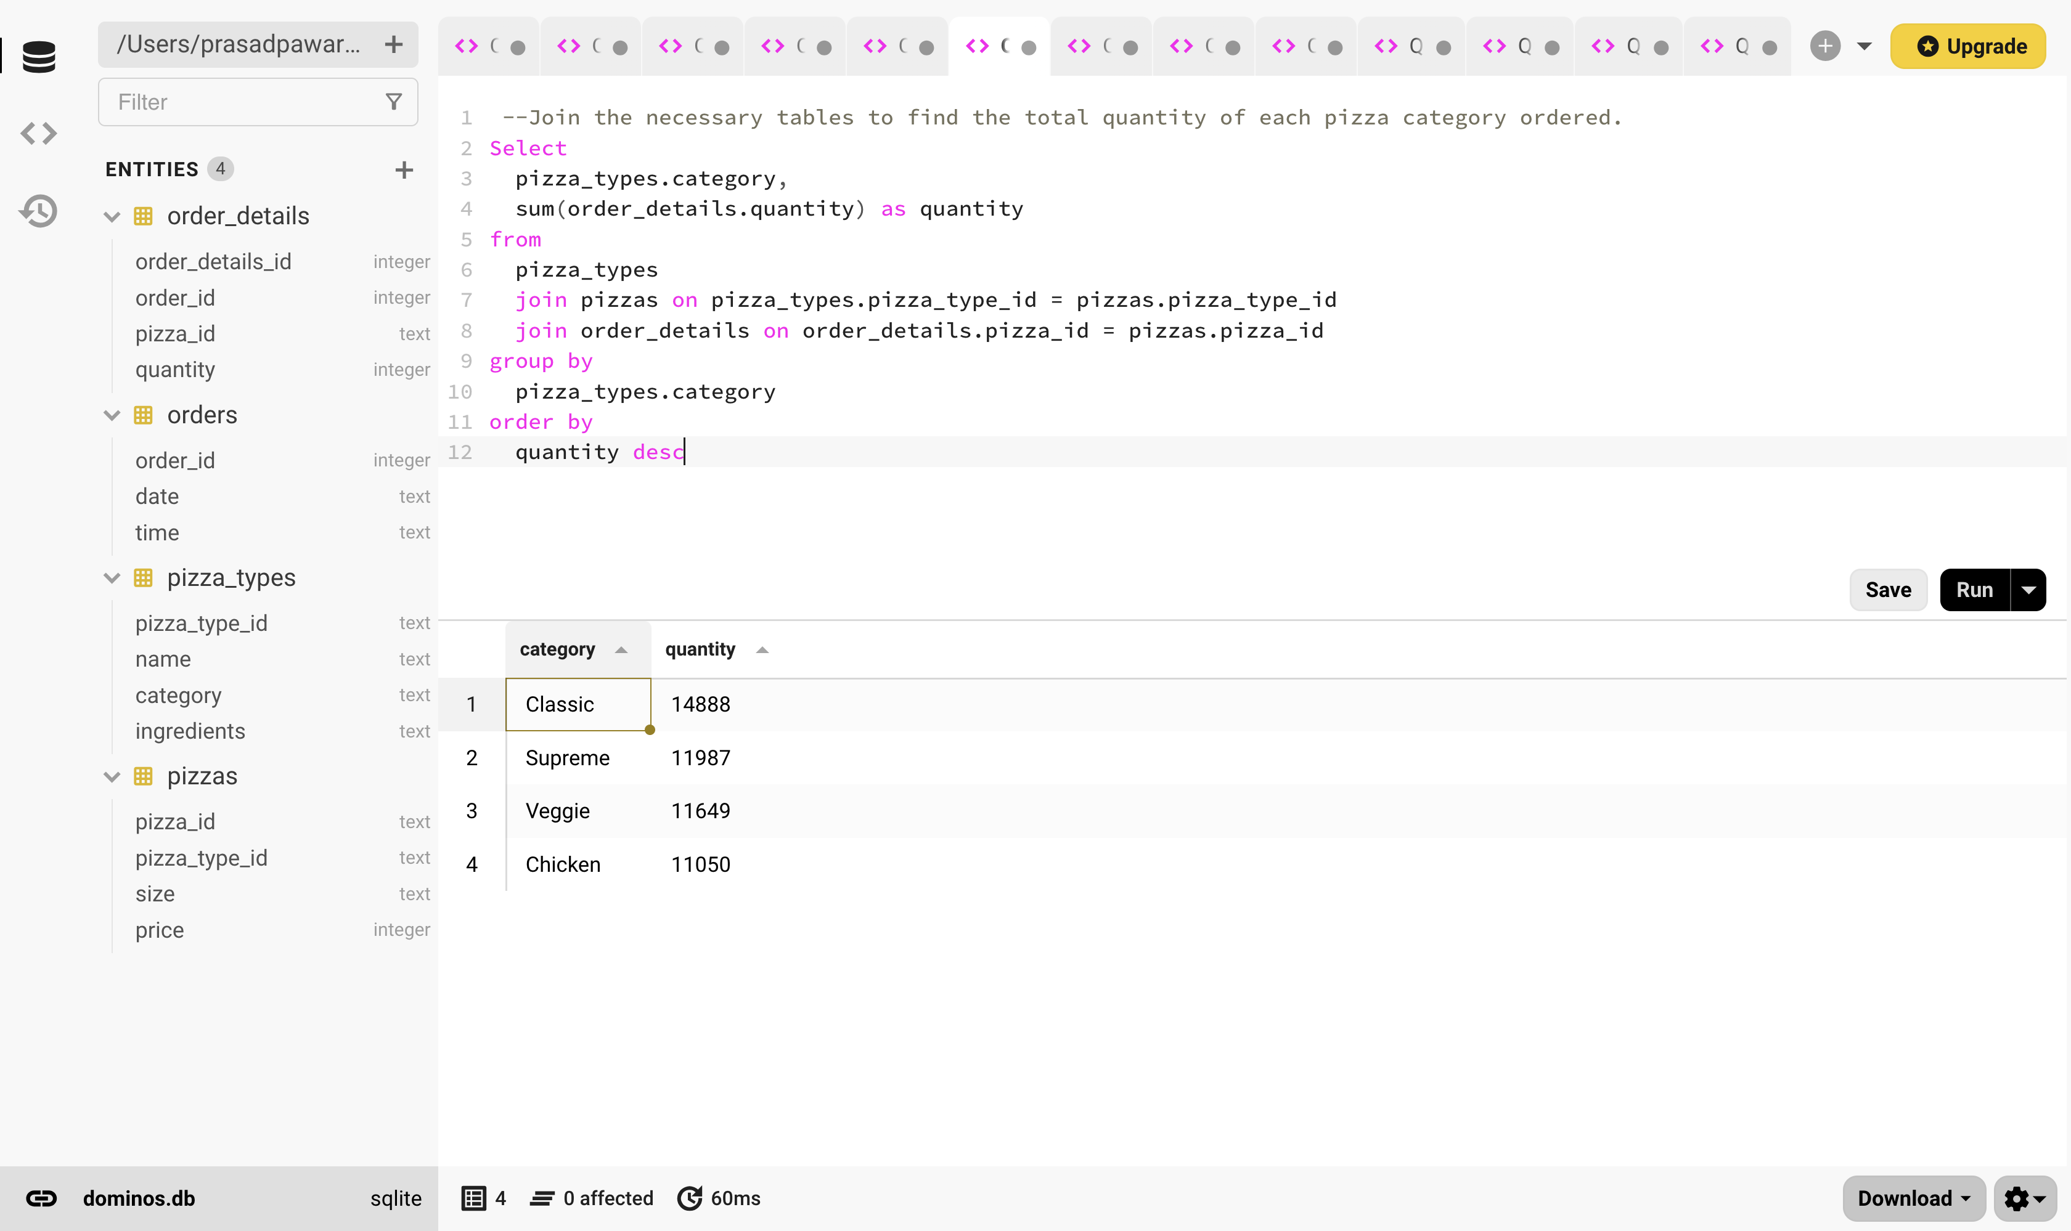
3. Determine the distribution of orders by hour of the day

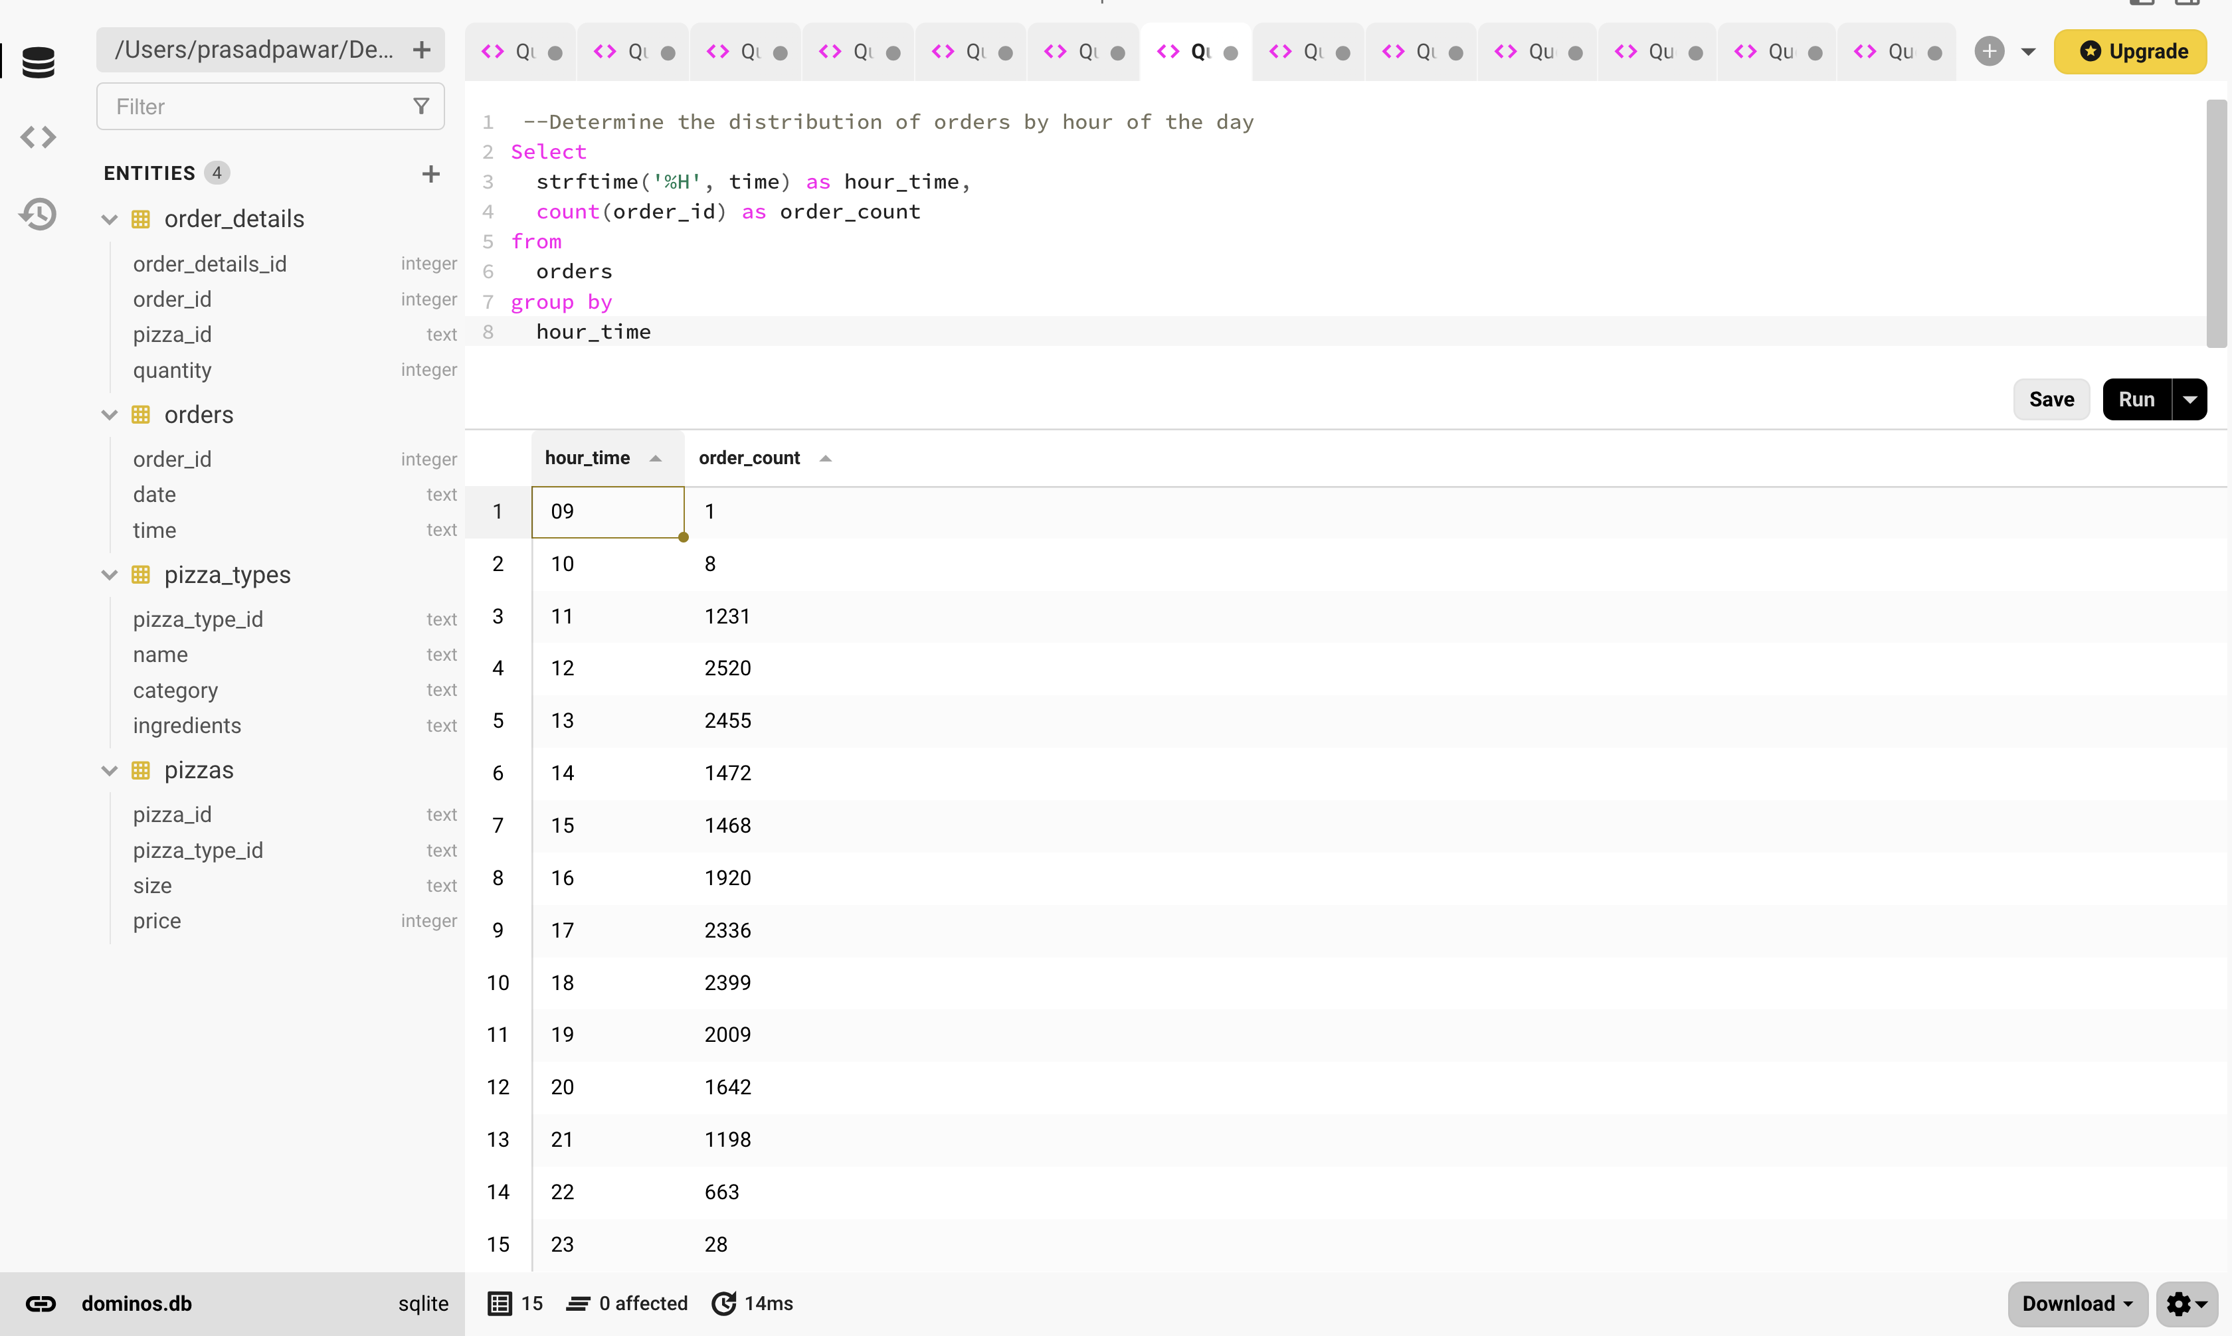

1. Join the relevant tables to find the category wise distribution of pizzas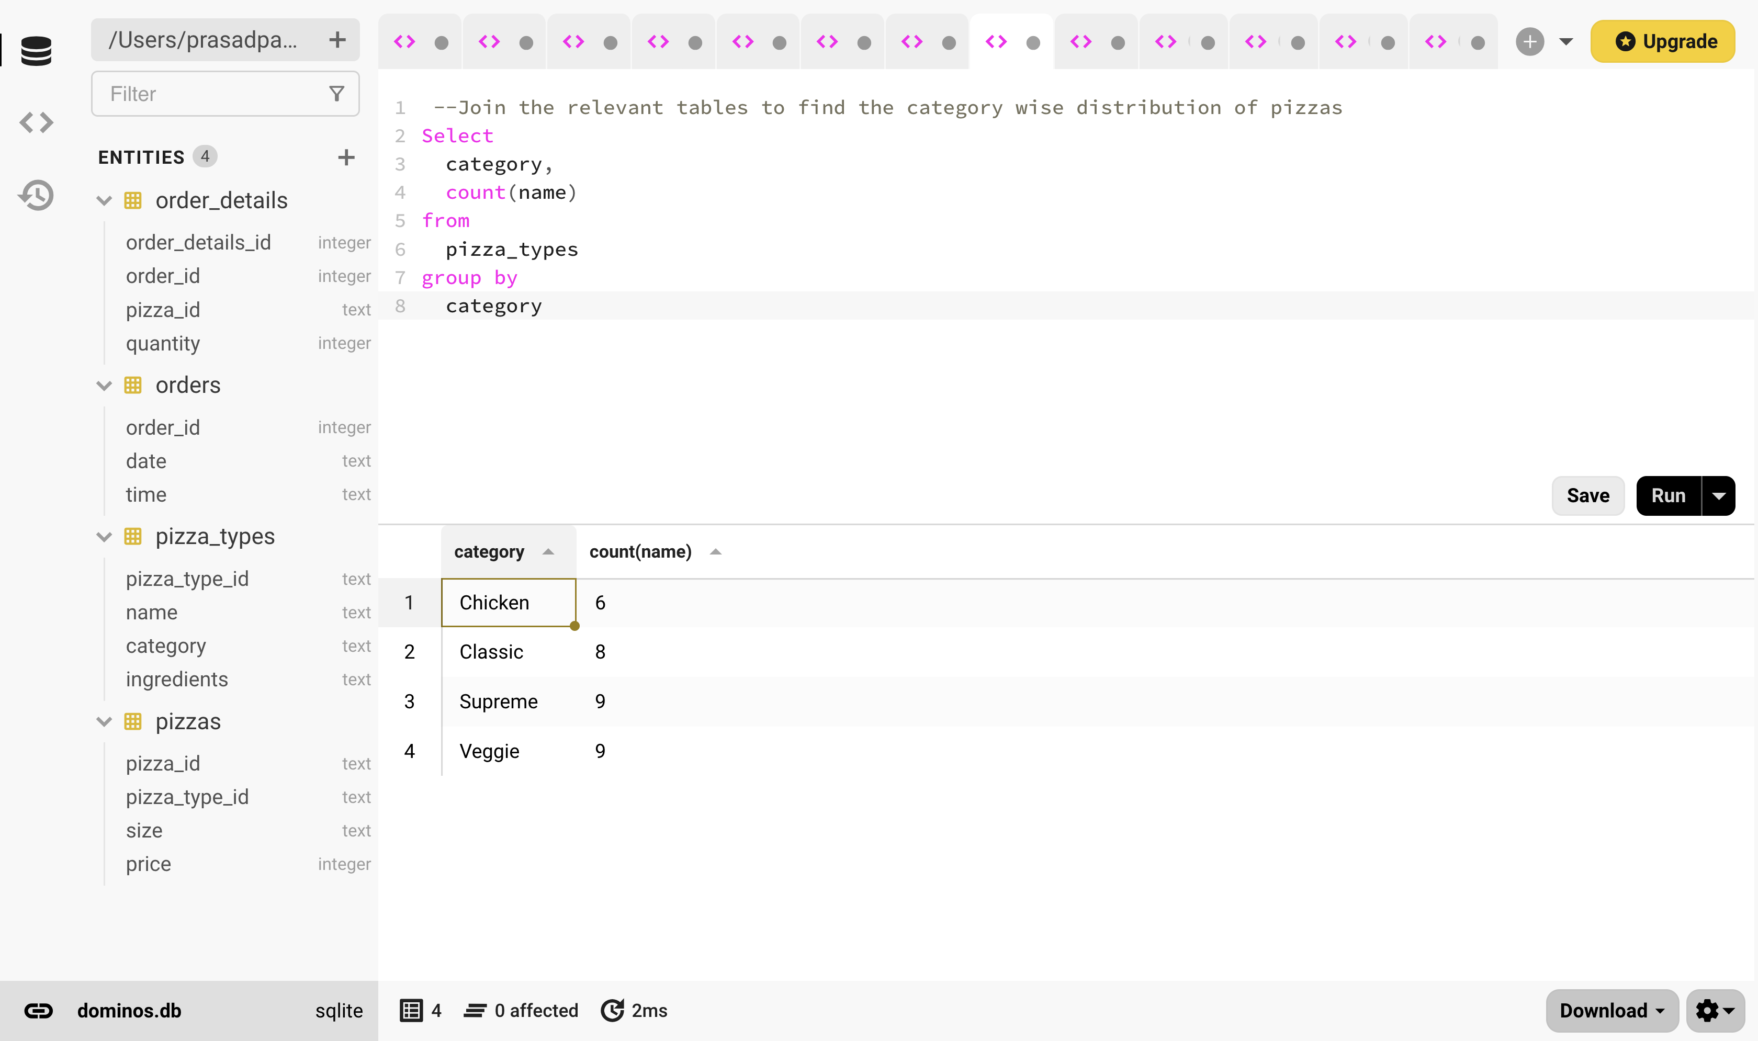
2. Group the orders by date and calculate the average number of pizzas ordered per day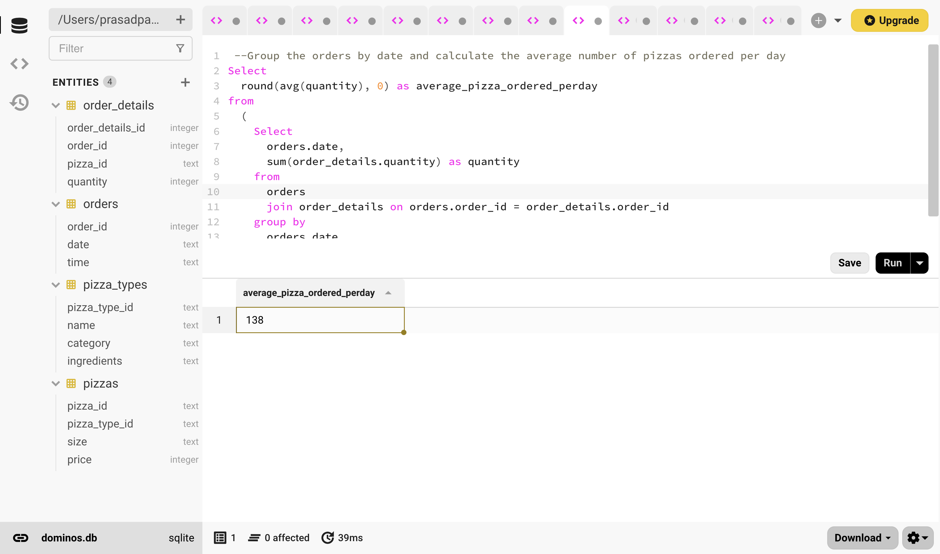
3. Determine top 3 most ordered pizza based on revenue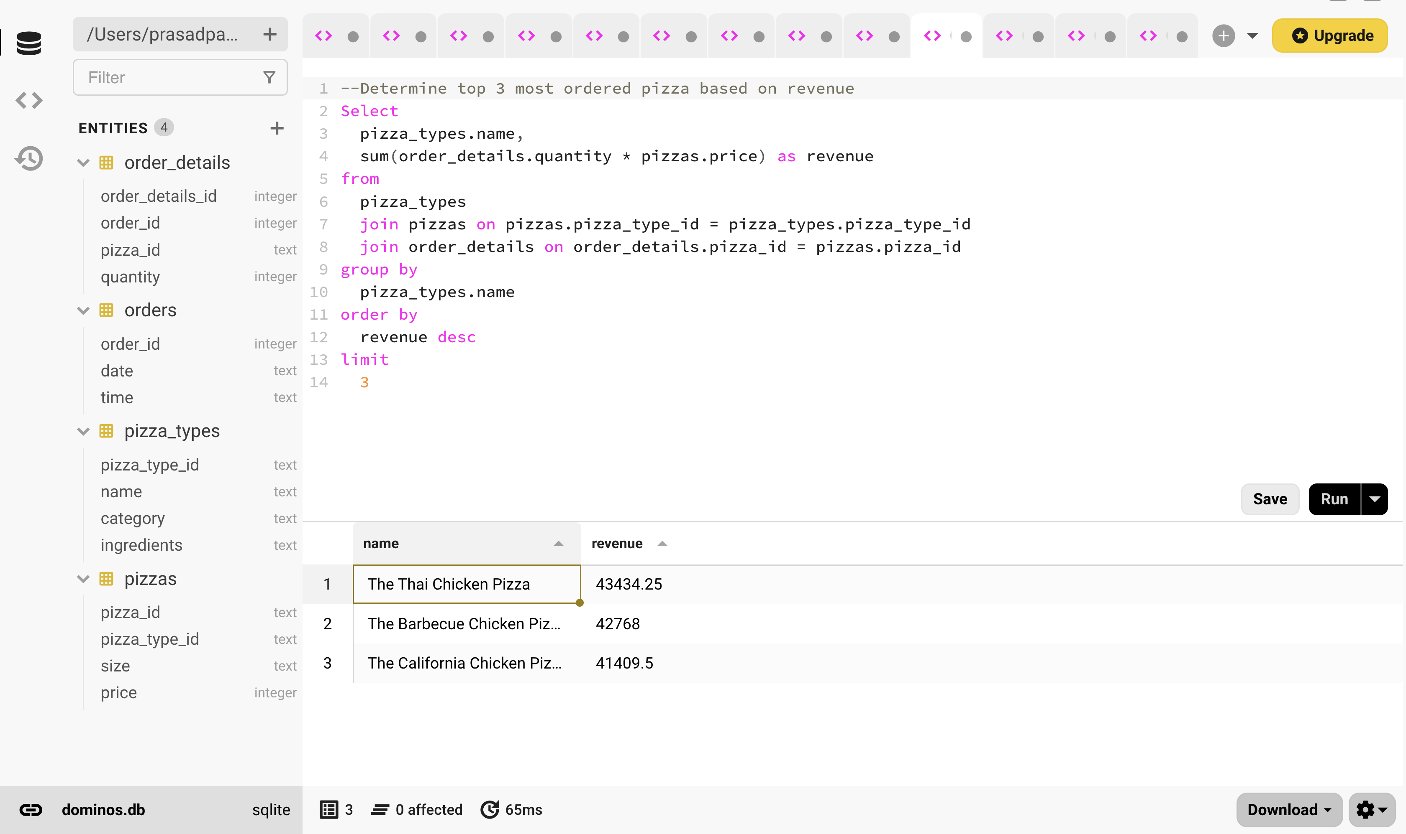
4. Calculate the percentage contribution of each pizza type to total revenue.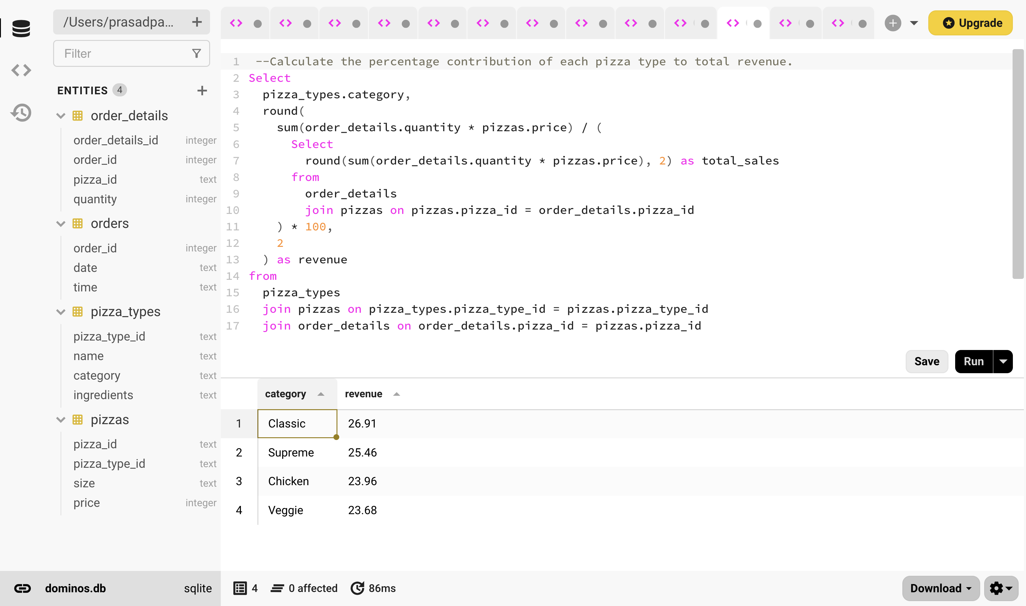
5. Analyze the cumulative revenue generate over time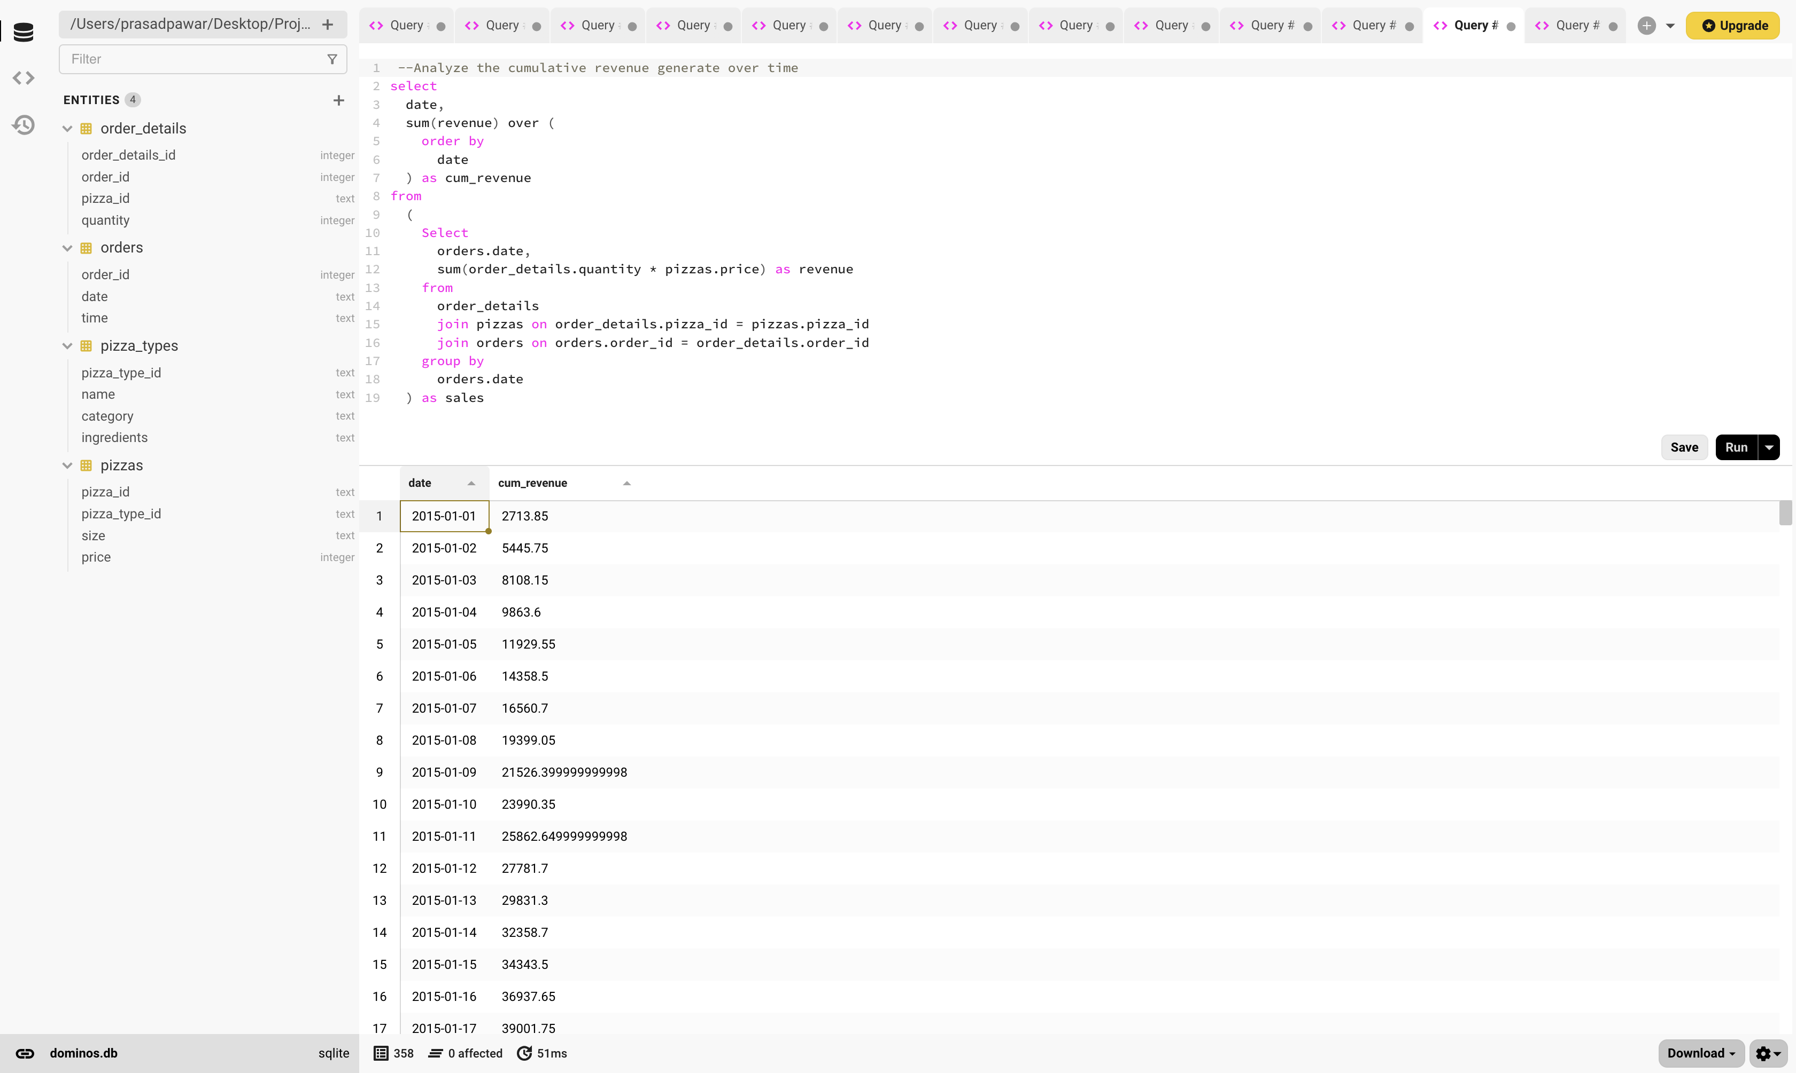
6. Determine the top 3 most ordered pizza based on revenue for each pizza category.

